Institute of Agrophysics Polish Academy of Sciences

Doświadczalna 4, 20-290 Lublin, Poland

20th International Workshop for Young Scientists

BioPhys Spring 2021

FIRST ANNOUNCEMENT

to be held
on 18th May 2021 in Lublin
in the form of video conference

Co-organizers:

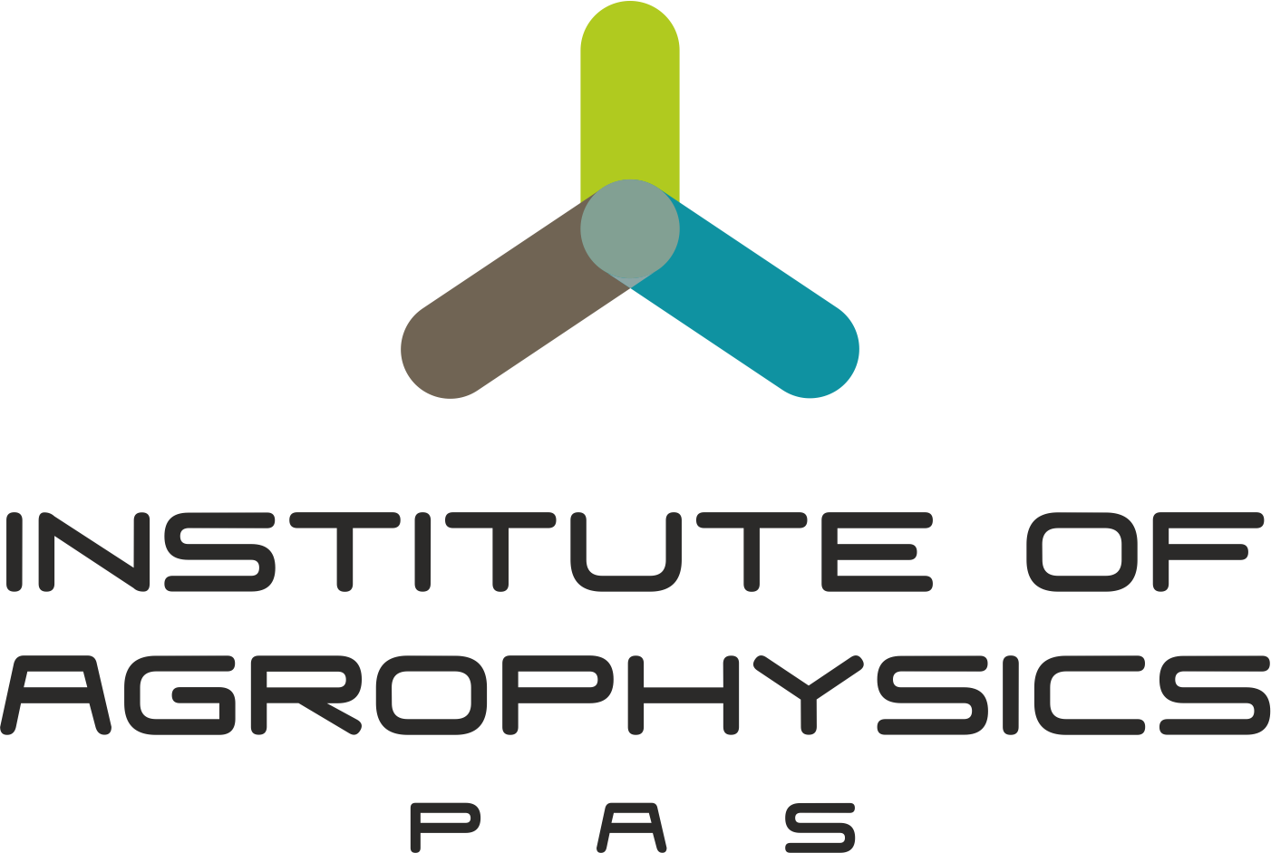 | INCLUDEPICTURE "http://bps2013.ipan.lublin.pl/uploads/logo_pan_lublin.jpg" \* MERGEFORMATINET INCLUDEPICTURE "http://bps2013.ipan.lublin.pl/uploads/logo_pan_lublin.jpg" \* MERGEFORMATINET INCLUDEPICTURE "http://bps2013.ipan.lublin.pl/uploads/logo_pan_lublin.jpg" \* MERGEFORMATINET INCLUDEPICTURE "http://bps2013.ipan.lublin.pl/uploads/logo_pan_lublin.jpg" \* MERGEFORMATINET INCLUDEPICTURE "http://bps2013.ipan.lublin.pl/uploads/logo_pan_lublin.jpg" \* MERGEFORMATINET INCLUDEPICTURE "http://bps2013.ipan.lublin.pl/uploads/logo_pan_lublin.jpg" \* MERGEFORMATINET INCLUDEPICTURE "http://bps2013.ipan.lublin.pl/uploads/logo_pan_lublin.jpg" \* MERGEFORMATINET  |  |  | 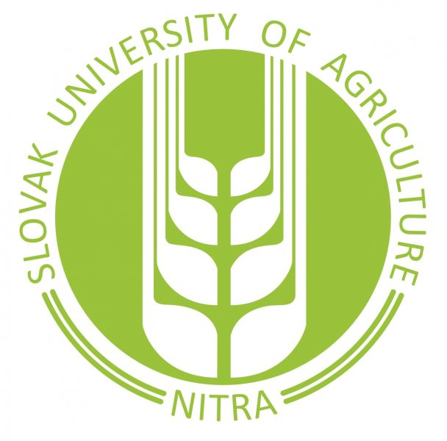
Dear friends and colleagues,

It is our privilege and great pleasure to invite you on behalf of organising institutions – the Institute of Agrophysics of the Polish Academy of Sciences, Lublin, Poland, together with Slovak University of Agriculture in Nitra, Slovakia, Hungarian University of Agriculture and Life Sciences, Gödöllő, Hungary, and Czech University of Life Sciences, Prague, Czech Republic – to participate in the 20th International Workshop for Young Scientists "BioPhys Spring 2021" to be held in Lublin on 18th May 2021 in the form of video conference.
The workshop is oriented on the deeper insight into the physical processes occurring in biological, agricultural and food systems. The workshop combines two basic tasks of international meeting: exchange of professional experience and integration of young people from different countries. We cordially invite young scientists to participate in the BPS 2021 Workshop and to present results of your research in application of physical methods to agriculture, biology and/or life sciences. The workshop is organised as an open English spoken event without any fee. One page abstracts of contributions will be published in the Book of Abstracts of the BPS 2021 Workshop.

Józef Horabik
Chairman of the Organising Committee

SCIENTIFIC COMMITTEE
- Prof. Józef Horabik, Institute of Agrophysics PAS, Lublin, Poland, chairman
- Prof. Artur Nosalewicz, Institute of Agrophysics PAS, Lublin, Poland
- Prof. Jiří Blahovec, Czech University of Life Sciences, Prague, Czech Republic
- Prof. Martin Libra, Czech University of Life Sciences, Prague, Czech Republic
- Prof. István Farkas, Hungarian University of Agriculture and Life Sciences, Gödöllő, Hungary
- Prof. István Seres, Hungarian University of Agriculture and Life Sciences, Gödöllő, Hungary
- Assoc. Prof. Zuzana Hlaváčová, Slovak University of Agriculture in Nitra, Slovakia
- Assoc. Prof. Ľubomír Kubík, Slovak University of Agriculture in Nitra, Slovakia
- Assoc. Prof. Vlasta Vozárová, Slovak University of Agriculture in Nitra, Slovakia
ORGANISING COMMITTEE AND CONTACT:

Józef Horabik – chairman
Phone: +48 81 74 450 61
j.horabik@ipan.lublin.pl

Artur Nosalewicz – vice-chairman
Phone: +48 81 74 450 61
a.nosalewicz@ipan.lublin.pl

Justyna Wajs – secretary
Phone: +48 81 74 450 61
j.gorminska@ipan.lublin.pl

Agata Pacek-Bieniek – secretary
Phone: +48 81 74 450 61
a.pacek-bieniek@ipan.lublin.pl

Contact address:
Institute of Agrophysics, Polish Academy of Sciences
Doświadczalna 4
20-290 Lublin
http://www.ipan.lublin.pl

DEADLINE
Submission of abstracts April 16th, 2021

Abstracts can be send by e-mail to Agata Pacek-Bieniek (a.pacek-bieniek@ipan.lublin.pl)
or uploaded through the web page of the BPS (available in March).

FORMAT of ABSTRACT

Instruction for abstract preparation is available in the attached Abstract Template.

REGISTRATION

Registration of participation in the BPS Seminar will be available through the web page of the BPS.
The web page of the BPS will be available in March.

LOCATION
Video conference on the platform Zoom will be coordinated by the Institute of Agrophysics PAS.

