Institute of Agrophysics Polish Academy of Sciences

Doświadczalna 4, 20-290 Lublin, Poland

20th International Workshop for Young Scientists

BioPhys Spring 2021

SECOND ANNOUNCEMENT

to be held
on 18th and 19th May 2021 in Lublin
in the form of video conference

Co-organizers:

 | INCLUDEPICTURE "http://bps2013.ipan.lublin.pl/uploads/logo_pan_lublin.jpg" \* MERGEFORMATINET INCLUDEPICTURE "http://bps2013.ipan.lublin.pl/uploads/logo_pan_lublin.jpg" \* MERGEFORMATINET INCLUDEPICTURE "http://bps2013.ipan.lublin.pl/uploads/logo_pan_lublin.jpg" \* MERGEFORMATINET INCLUDEPICTURE "http://bps2013.ipan.lublin.pl/uploads/logo_pan_lublin.jpg" \* MERGEFORMATINET INCLUDEPICTURE "http://bps2013.ipan.lublin.pl/uploads/logo_pan_lublin.jpg" \* MERGEFORMATINET INCLUDEPICTURE "http://bps2013.ipan.lublin.pl/uploads/logo_pan_lublin.jpg" \* MERGEFORMATINET INCLUDEPICTURE "http://bps2013.ipan.lublin.pl/uploads/logo_pan_lublin.jpg" \* MERGEFORMATINET  |  |  | 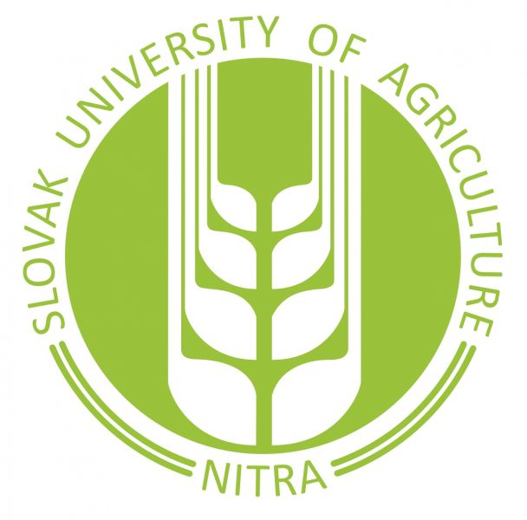
Dear friends and colleagues,

We are delighted to receive very big interest in participation in the BPS Seminar. We received 47 registered abstracts. Thank you very much for your interest and expressed willing of participation in the Seminar.
Due to the big number of presentations it was impossible to organize the BPS Seminar as planned the one day Session. Therefore, we decided to extend the BPS Seminar into two days event: i.e. 18th and 19th May 2021. We believe that the introduced change into the BPS program will not disturb so much in your other duties scheduled for 19th May.
Enclosed please find detailed programme of the BPS seminar divided into eight topics sessions. The programme is available also on the web page of the BPS https://biophys.ipan.lublin.pl/ According to the schedule of the programme ten minutes of time is planned for each presentation. In practice it means eight minutes for presentation of a contribution, one minute for discussion and one minute for switching from one presentation to another. Therefore, our request to all participants is to prepare very short but still informative presentations.
We are looking forward to meet you on the BPS Seminar very soon on 18th and 19th May.
With the best regards,
Józef Horabik
Chairman of the Organising Committee of the BPS Seminar

SCIENTIFIC COMMITTEE
- Prof. Józef Horabik, Institute of Agrophysics PAS, Lublin, Poland, chairman
- Prof. Artur Nosalewicz, Institute of Agrophysics PAS, Lublin, Poland
- Prof. Jiří Blahovec, Czech University of Life Sciences, Prague, Czech Republic
- Prof. Martin Libra, Czech University of Life Sciences, Prague, Czech Republic
- Prof. István Farkas, Hungarian University of Agriculture and Life Sciences, Gödöllő, Hungary
- Prof. István Seres, Hungarian University of Agriculture and Life Sciences, Gödöllő, Hungary
- Assoc. Prof. Zuzana Hlaváčová, Slovak University of Agriculture in Nitra, Slovakia
- Assoc. Prof. Ľubomír Kubík, Slovak University of Agriculture in Nitra, Slovakia
- Assoc. Prof. Vlasta Vozárová, Slovak University of Agriculture in Nitra, Slovakia
ORGANISING COMMITTEE AND CONTACT:
Józef Horabik – chairman
Phone: +48 81 74 450 61
j.horabik@ipan.lublin.pl

Artur Nosalewicz – vice-chairman
Phone: +48 81 74 450 61
a.nosalewicz@ipan.lublin.pl

Justyna Wajs – secretary
Phone: +48 81 74 450 61
j.gorminska@ipan.lublin.pl

Agata Pacek-Bieniek – secretary
Phone: +48 81 74 450 61
a.pacek-bieniek@ipan.lublin.pl

Contact address:
Institute of Agrophysics, Polish Academy of Sciences
Doświadczalna 4, 20-290 Lublin http://www.ipan.lublin.pl https://biophys.ipan.lublin.pl/

LOCATION
Video conference on the platform Zoom will be coordinated by the Institute of Agrophysics PAS.

